

The Wimbledon Club

Tennis Member Handbook
2025 to 2026

Welcome to The Wimbledon Club

Welcome to The Wimbledon Club’s Tennis Section, part of a thriving and busy multi-sports club nestled in the leafy suburbs of Wimbledon. We look forward to an enjoyable year of tennis at our club across both our adult and junior programmes and we hope to see as many of you around the club as possible taking part in many aspects of club life.

The Club offers members the opportunity to play socially, in box leagues, club tournaments, inter-club matches and in teams which compete throughout the year in county and national competitions.

There are also comprehensive adult and junior coaching programmes, providing group and individual coaching, including Cardio Tennis and Walking Tennis, throughout the week. Our LTA Junior Tennis Programme offers popular termly group sessions, thriving holiday tennis camps and junior social tennis. We also have a highly qualified team of LTA accredited tennis coaches who are available for private and small group lessons for members, and a high-quality ball machine which can be hired out for a small fee.

We have 16 high quality tennis courts (including 6 beautifully maintained grass courts), with 3 of these covered by an indoor Dome in the winter months.

We have a great restaurant and bar area in the clubhouse, providing an excellent food and beverage, with the balcony overlooking the grass courts a perfect space to relax, unwind and enjoy the club. The tennis club is proud to be sponsored by Babolat.

The tennis section is governed by the Tennis Committee and run on a day-to-basis by the Tennis Director and Tennis Administrator.

The Tennis Committee

Andrew Finkelstein Chairman

Dorothy Lim Honorary Secretary

David Serra

Orestis Tzortzoglou

David Ross

Peter Anthony Glick

Nicola Milburn

Tennis Staff

Tennis Director – Erwan Nicolas

Email: director@TWCtennis.co.uk

Tennis Administrator – Rosanna Ball

Email: admin@TWCtennis.co.uk

Junior Tennis Head Coach – Bailey Robbins
Email: juniorheadcoach@TWCtennis.co.uk

Code of Conduct

Introduction
This code of conduct and policy on court etiquette sets out what the Club regards as good practice for all members to follow and is available so that every member is clear as to what is expected of them in order to create the right playing environment in which everyone can enjoy their tennis.
Both the code of conduct and the policy on court etiquette reflect the friendly and co-operative spirit which members at the Club have enjoyed for many years, as well as advice from the LTA. The Tennis Committee of the Club is confident that this ethos will continue and sees this as important in maintaining the Club’s reputation.
The Code of Conduct sets out minimum standards of behaviour, which all members are expected to follow, and seeks to avoid any serious issues arising. The policy on court etiquette then sits alongside the code of conduct and sets out a range of actions and behaviors, which are considered acceptable or unacceptable on and around the tennis court.
Should a breach of the code of conduct or a serious breach of the policy on court etiquette occur then the Club has a complaints procedure to deal with that.

Aims of the Code of Conduct
The aims of this code of conduct and policy on court etiquette are to:
- Ensure that all members are treated fairly and with respect;
- Advise all members of the standards of behavior and court etiquette which they are expected to meet so that an environment is created within which members can enjoy their tennis and the Club can continue to flourish

Standard of Behavior
All members are expected to treat all other members and all other players respectfully. The Club will not accept any behavior which may cause any physical or mental harm to any other member or player.

Unacceptable actions will include:
  - Being abusive or showing aggression towards another member or player;
  - Swearing;
  - Racket throwing;
  - Intimidating another member or player;
  - Creating a danger to another member or player;
  - Calling into doubt the integrity of another member or player such as by repeatedly querying line calls.

On Court Etiquette
Tennis etiquette covers different areas from those addressed within the rules of the game. Etiquette covers a range of actions and behaviors which are considered acceptable on and around the tennis court.
The TWC Tennis Section policy on etiquette covers these areas:

Showing respect and being courteous
  - Welcome new members and players to the Club irrespective of their experience of the game and their level of play;
  - Show respect and courtesy to your partner, your opponents, staff and others on or around the courts;
  - Instead of criticizing your partner or opponent, offer encouragement instead;
  - If a loud dispute during a match occurs, take it off court and away from other players on adjacent courts;
  - Do not walk behind courts when a point is in progress to avoid causing a distraction;
  - During play and particularly between games keep the amount and volume of conversation to a minimum so as to avoid distracting players on other courts;
  - If a ball from an adjacent court strays onto yours do not hit it back immediately but do so when the players on that court are ready and then hit it to the server’s end of that court;
  - Courtesy to your opponents should include leaving the court together at the end of the match.
  - Do not stand at the side of a court and talk
  - Do not walk onto another court during a game
  - Before crossing a court to get to yours, wait for the conclusion of the point or if the match is a competitive one, wait until the end of game, or until you are invited to cross, and do so as quickly as possible;
  - Close the gate behind you, as you would on your own court;
  - Be aware if you are already playing on court that others may wish to cross your court in order to access their own court and facilitate that where possible.
  - If your ball rolls onto an adjacent court, wait for a break in the play in that court before politely requesting its return rather than retrieving it yourself.

Line calls
  - Only call the lines on your side of the net;
  - Call clearly on the basis of what you honestly believe to be correct;
  - If you are not certain, or did not see the ball clearly, the ball was good and the doubt must be given in favour of the opponent;
  - If occasionally you have serious doubt over a line call, ask your opponents politely if they are certain as to the accuracy of their call, and if they are, move on and play the next point;
  - If there is doubt over a line call, consider offering to replay the point.

Keeping score
  - The server should announce the score before each point;
  - If the server forgets or does so inaudibly, the receiver should request the server to make an audible announcement of the score.

Mobile phones
  - Mobile phone calls should not be made or received on court; leave the court to make or receive a call;
  - Mobile phones taken onto court should be switched off, or put on silent or vibrate mode, so as to avoid creating a distraction.

Clothing and footwear
  - Players should wear recognised tennis clothing of any colour together with tennis footwear;
  - Tennis footwear is required both to promote safety as unsuitable footwear can provide insufficient grip, and also to prevent damage to the courts.
  - Pimpled grass court shoes should not be worn on the grass courts

We ask all members to pay attention to the above rules of etiquette and not be offended if you are reminded by a member of staff, committee member or other member of the Club.

Court Booking User Guide

All members are put on our online court booking system called MYCOURTS® when you join the Club.

Logging into mycourts

All courts are bookable on the Mycourts® booking system.

You can log into your account via the following link:
http://thewimbledonclub.mycourts.co.uk and log in using your username and password.

If you have any issues with logging in or accessing your username and password, please contact admin@twctennis.co.uk

Adding credit to your booking account

Every member has a personal booking account which holds credit for the purpose of making an indoor booking, paying a guest fee or booking onto a group session. Your balance is shown on the left of the screen after you log in. Bookings may only be made if enough credit exists in your account to cover the booking
fee. Please add credit by paying online using a debit/credit card.

Paying Online
Log in and choose the “Buy Credit Online” option and follow the instructions. You can choose the amount of credit you wish to add in a single transaction.

Making a court booking

Select the day you wish to make a booking from the ‘Booking Sheets’ menu. Members may book grass courts online from 10am the day before play, and non-grass courts online from 10pm up to 8 days in advance for peak members and off-peak members.

Select the court and time(s) you wish to book and confirm the booking.

Guest fees

Members must pay for their guest fees at the time of booking by selecting the appropriate guest fee from the drop-down menu when selecting their playing partners. If a member is bringing 3 guests, then 3 guest fees must be paid as playing partner 1, 2 and 3. Guest fees stated are per visit per guest.

Please note: Members only need to select their guest fee(s) for the first 30 minutes of their booking. To ensure you are not over charged, please UNTICK the box that automatically adds your playing partner into each 30-minute slot of your booking.

If you have any issues, please contact admin@twctennis.co.uk

Court | Peak Guest Fee  (6pm-10pm Mon-Fri) (7am-6pm Sat/Sun) | Off Peak Guest Fee  (7am-6pm Mon-Fri) (6pm-10pm Sat/Sun)
Grass | £20 | £10
Indoor | £15 | £8
Outdoor | £10 | £6

Please note:

If a member has accidentally selected the incorrect guest fee for their booking, the tennis section reserves the right to adjust the fees accordingly on their MyCourts account.

Arrival

If you are not playing within 15 minutes of your booking start time, you forfeit your booking rights and another member is entitled to use the court for the duration of your booking.
Booking cancellations and refunds

As a courtesy to other members, all members must cancel a court as soon as possible so that the court may be booked by others.

To cancel a court, log in and select “My Bookings”. Your booking fee is automatically refunded as credit in your account when cancelling at least 24 hours prior to your booking.

Personalising your account

Log in and select “My bookings”, “My Settings” and “My Profile” tabs to personalise your booking account.

My Bookings contains all your bookings, including those made by other members who have selected you as a playing partner. Useful features include: click on the envelope to send an email message to an opponent for a booking; click on an opponent’s name to view their contact details; click “cancel” to cancel a booking.

My Settings allows you to change your password, PIN and subscribe/unsubscribe from email alerts including confirmation of your court bookings/cancellations and cancelled court alerts (select the days of the week and times of interest to you)

My Profile allows you to see and edit how you appear to other members in the members’ directory. Upload photos and edit your contact details and member profile.

Turning on floodlights

Lights for the floodlit courts will automatically turn on when you have a court booking after sunset. Floodlights are charged at £1 per hour booking, and this is debited from your account at the time of booking.

Court Booking Rules

Booking rights

Peak adult and off-peak members may book grass courts from 10am the day before play and non-grass courts from 10pm up to 8 days in advance.

Junior Tennis members (aged 8- to 17-year-olds) may book 1 hour per day, on any court at any time, up to 8 days in advance. Junior Tennis members may book a maximum of 2 hours court booking time per week.

All members and coaches must enter the names of their playing partners/clients at the time of booking or at least 24 hours prior to playing. If no playing partner is added, we will assume you brought a guest and charge the appropriate fee.

When cancelling a clay court in favour of a grass court, members must first cancel their clay court so that court becomes available for other members to book. The member booking a grass court must also ensure that all playing partners are named on their new booking.

PLEASE NOTE: The groundsmen reserve the right to close any grass court(s) on the day of play if they deem it unplayable due to rain or schedule it for rest. Therefore any grass courts booked before the day of play
are booked at members own risk. The status of the grass courts will be confirmed by no later than 10am on the day of play. Please check on mycourts for the status of the grass courts on any given day. If a court is labelled as "closed" on the booking sheets, then it will not be available for play that day and any bookings on that court will not be able to go ahead.

Member booking fees

Booking fees only apply to indoor courts and are shown below.

Indoor Court | Booking Length | Peak Price  (6pm-10pm Mon-Fri) (7am-6pm Sat/Sun) | Off Peak Price (7am-6pm Mon-Fri)  (6pm-10pm Sat/Sun)
Doubles Court  Singles Court | 60 minutes | £16 | £10
Doubles Court  Singles Court | 90 minutes | £24 | £15
Doubles Court  Singles Court | 60 minutes | £12 | £8
Doubles Court  Singles Court | 90 minutes | £18 | £12

Coaching courts

Service Providers (Tennis Coaches at TWC) may book courts for private lessons subject to the following conditions (which can be amended by the Tennis Committee at any time and without notice):
- Coaches may book courts up to 14 days in advance. Member’s name MUST appear on the booking sheet at time of booking. Court rental is £8 per hour for coaches and is automatically debited from their MyCourts account when they book a court. Only 2 coaches can coach at the same time when booking in advance, on the day there is no limit.
- Coaches must cancel courts at least 24 hours in advance of the booked time, failing which that time will count towards the total rental.
- Grass Courts must not be used by Service Providers for private lessons at any time.
- TWC Coaches can book Court 8, 11 and 16
  - Monday to Friday 7am – 7pm. No bookings past 7pm.
  - Saturday and Sunday from 7am – 2pm and 6pm to 9pm. No bookings between 2pm and 6pm.
  - TWC Coaches can book other courts on the day between the same time periods except grass courts.
  - Mini Court can be booked by coaches from 7am to 7pm Monday to Friday and from 7am – 9pm Saturday and Sunday.
- Members are not permitted to book courts in their name for coaching.
- Coaches are not permitted to coach children under 8 years old.
- Coaches are not permitted to coach non-members.
- Coaches are not permitted to compete for TWC teams.

Matches

Court bookings for all representative club matches, including adult and junior teams and singles matches where opponents travel from an external club, take priority over all other court bookings.

All representative club matches must be booked by the Tennis Administrator.

Court bookings for the Club Championships must be booked by competitors who may book consecutive slots to ensure completion of their game within their booking time.

In exceptional circumstances, where matches run over their allocated booking slot, inconvenienced members will be fully refunded and their next booking provided free of charge.

Club bookings

From time to time the club may book tennis courts for multi-sport functions and events. The tennis committee works closely with the general committee to ensure these events are in the best interests of the club and the benefit to the tennis section outweighs any inconvenience to tennis members.

The Sports Hall is a multi-purpose sports hall and this facility is shared equally between the Club’s tennis, cricket and hockey sections.

External bookings

The club occasionally receives external requests for court bookings. Each request is considered by the tennis committee on a case-by- case basis. External bookings are only approved if they provide a clear benefit to
the club and tennis section at minimal inconvenience to tennis members.

Safeguarding

The Wimbledon Club has a duty of care to safeguard and promote the welfare of all children, young people and adults at risk, to protect from any type of abuse and to ensure everyone feels welcome and can enjoy their time at the club.
All of our Tennis Coaches, Level 2 and above are LTA Accredited meaning they have all completed regular Safeguarding Training. We follow the LTA requirements and encourage and maintain a culture, where people feel they can raise a concern and appropriate action will be taken.
​
We are committed to ensuring that anyone regardless of their age, abilities, race, sexual orientation or religion are treated fairly with no discrimination.
​
If you have any concerns please contact our Welfare Team
Jared Brading
Safeguarding Manager for TWC on 07415 105560 safeguarding@twcsport.co.uk
Erwan Nicolas
Tennis Director 07950 697024 director@twctennis.co.uk
​
In an emergency please call 999​
If you do not feel comfortable contacting our Welfare Team, please contact​
LTA Safeguarding Team 0208 487 7000
NSPCC 0808 800 5000
Childline 0800 1111

Adult Tennis Programme

The Wimbledon Club has an adult programme that is aimed at different levels and standards of players.

Currently Pickleball and Walking Tennis are available to non members as well as members.

Please see details of all of the adult tennis programmes below.
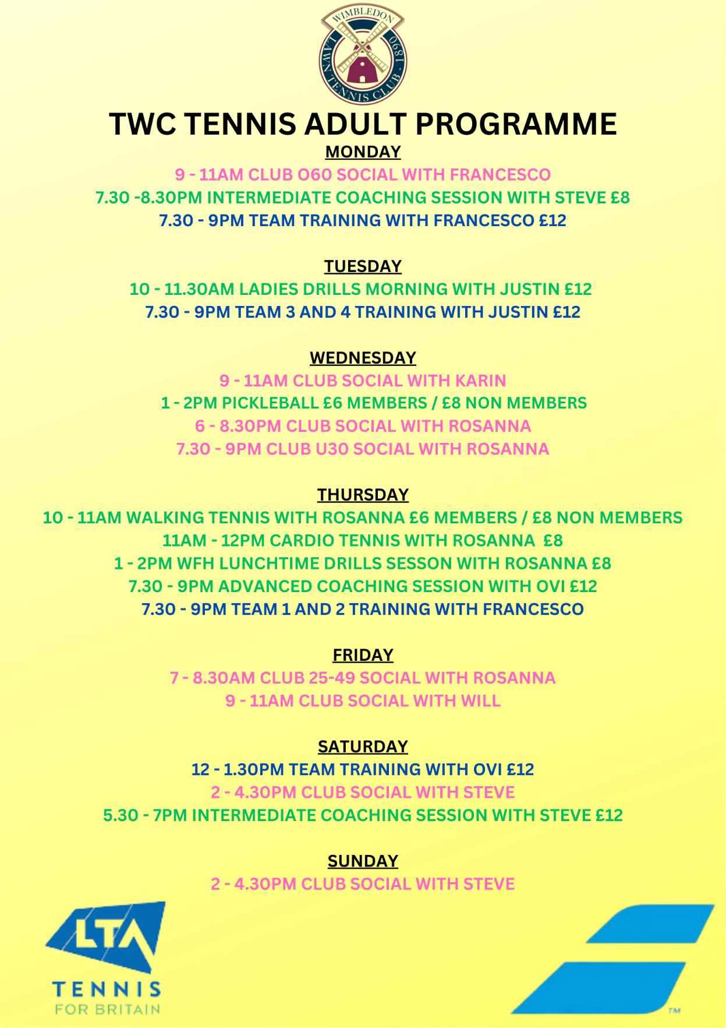

Adult Competitive Play

At The Wimbledon Club we run internal box leagues in a variety of formats to give members the chance to meet others of a similar level in a more competitive environment. There are Spring, Summer and Autumn Box Leagues.

If you would like to be included please contact Rosanna admin@twctennis.co.uk

Our Club Championships run from April through to mid June. There are Open, +45 and +60 and Handicap tournaments in singles and doubles, suitable for all members.

TWC have 17 different teams competing in various Surrey Leagues in different age groups. Each team has team training and a team captain. Please contact Erwan if you wish to join a team for a trial.

Throughout the year we play in friendly matches with other clubs from our area and abroad. We also organise Social Tournaments and more competitive tournaments throughout the year.

TWC Coaches

Coaches are available for 1 to 1 or 1 to 2 lessons. Please contact coaches directly to arrange. You will pay the coach directly. There is a 24 hour cancellation policy although the weather will be taken into account.

Junior Tennis Programme

The aim of our programme is to provide a fun and inclusive environment for children of all abilities. We want to provide a platform for children to develop their skills to a point where playing tennis is an acquired skill and something they will be able to play for the rest of their lives. We believe playing tennis is fantastic for a child's life skills and will teach them the important qualities of teamwork, honesty, fairness, dedication, endurance and speed. For those children who excel and wish to compete at an even higher performance
level, we can recommend external programmes that they can attend to supplement their development.

Junior Tennis Membership

Membership Category | Age (as of 1st October in the current membership year) | Price
Junior | 6 to 17 years old | £215

For all information relating to Junior Tennis, please contact juniorheadcoach@twctennis.co.uk

Rules for Juniors

Junior Tennis members may book 1 hour per day, on any court at any time, up to 8 days in advance. Junior Tennis members may book a maximum of 2 hours court booking time per week

